**Creative Computing with **

**Creating a Creative World - Building a Better World**

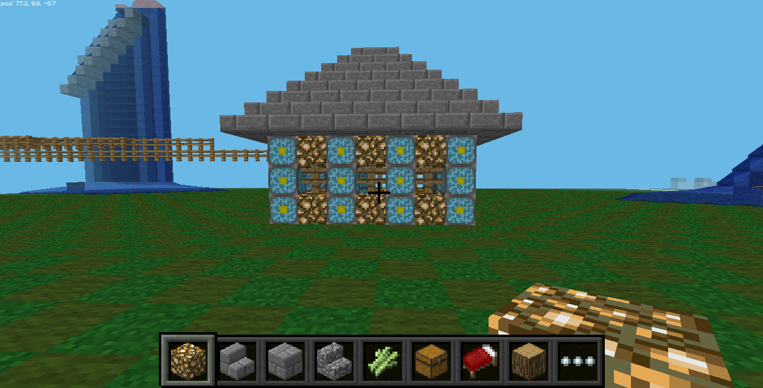

Learners critically evaluate their world and surroundings and use Make Art and Make Minecraft to picture a more ideal world.

|  |  |  |
| --- | --- | --- |
| **Title: Building a Better World Pt 1**  **Time: 1 hour 30 minutes**  **Level: Beginner to Intermediate**  **Note*** This lesson can occur over a few days. Recommended 2 days** | | |
| Learning Objectives:   * Learners to get introduced to product development and a popular framework, design thinking * Learners to get exposure to Kickstarter and the idea of raising money to start a business * Learners to understand the importance of getting and giving feedback when designing a product | | |
| * Through a variety of creative and practical activities, pupils should be taught the knowledge, understanding and skills needed to engage in an iterative process of designing and making. They should work in a range of relevant contexts [for example, the home, school, leisure, culture, enterprise, industry and the wider environment]. | | **Standards:**  **UK National Curriculum** |
| * K3-5: 1B-A-5-3 Create a plan as part of the iterative design process, both independently and with diverse collaborative teams (e.g., storyboard, flowchart, pseudo-code, story map). | | **Standards:**  **US Computer Science Teachers Association** |
| **Materials Needed:** [Design Thinking Lesson](https://docs.google.com/document/d/1QCjaibHTzm-mdKhBEUwLbqLf50nBYdXxBWJm1EpYY9k/edit?usp=sharing) | | |
| **Linking: 10 min (5 min - write, 5 min share)**  If you could change one thing about your community what would it be? Do you want access to more parks and bike lanes? Do you want a heavy metal concert to happen every Friday? Take a few minutes to write or draw your thoughts out.  Once students are done, have a few people share out their thoughts on what they would like to add to their community space.  **Engage: 5 min**  For the next few days we want to think of ourselves as engineers, policy makers, and activists. There are a lot of problems in our community, but that means that there are a lot of creative solutions to these problems! | | |
| **Collect Kanos:** 5 min  **Retrieve Computers, Turn On, Log In..** | | |
| **Exploration Activities:** (45 min)  **Challenge 0: What is Design Thinking?**  If your students have forgotten, review what [Design Thinking](https://docs.google.com/document/d/1QCjaibHTzm-mdKhBEUwLbqLf50nBYdXxBWJm1EpYY9k/edit?usp=sharing) is. Make a note that we will be using this thought process to think of ways we can improve our communities.  **Challenge 1: Community Problems + Solutions**  So what does Design Thinking have to do with anything? Well, today we are all going to receive a challenge. Before we do this, break into groups of 4.  You are a team tasked with identifying a problem in your community and propose an innovative solution to solve that problem.    In groups of four, you will need to:    Identify the problem in your community  Use design thinking to define your problem  Use Kano to prototype and test a solution  Pitch your proposal to the class    Be creative! You can choose any app (Minecraft, Make Art, Make Music) to express your ideas.    Students work on defining their problem, ideating, and coming up with ideas for their test and prototype. They come up with a plan to use Kano to express their ideas.    **Save your work and share to Kano World!** | | |
| **Sharing: 15 min**  Students will share their ideas (as they are now) with the class. Ask students to state what the problem identified was, why it was important to them, and then their creative idea.  **Evaluation: 5 min**  Before students leave have them write on a sheet of paper what was difficult about this challenge. As well, have them answer how they overcame this difficulty.  **Closing:**  As a homework extension have students finish their proposed solutions to the challenge. They can also spend the next day in class finalizing their work | | |
| **Kano Cleanup:** 5 min  **Power down and put away the Kanos** | | |